EX.NO:4 | DATA MODELLING AND FORM DESIGN FOR A BUSINESS APPLICATION IN ZOHO CREATOR
SAHANA R
241401086
Gym Membership Enrollment Form

Aim
To design and build a functional “Gym Membership Enrollment Form” application in Zoho Creator that demonstrates the correct usage of all thirteen Basic Fields available in the Form Builder, while solving a real fitness-center requirement of collecting and managing new member enrollment details in a structured manner.

2. Procedure
2.1 Problem Statement & Application Scope
A fitness center currently uses printed forms for new member enrollment, which can cause missing or unclear information. The gym needs a structured system to maintain member details, fitness goals, preferences, and health information.
Design a low-code Zoho Creator application that allows members or front-desk staff to submit enrollment details through a single online form.
Application Name: Gym Membership Enrollment & Front Desk Management
Form Name: Membership_Enrollment_Form
Report View: Membership_Enrollment_Report

2.2 Data Model & ER Diagram
The Data Model represents the structure of the Membership_Enrollment_Form. The main entity is Membership Enrollment, which stores member details, contact information, membership plan, fitness preferences, workout schedule, and health declaration using Zoho Creator Basic Fields.

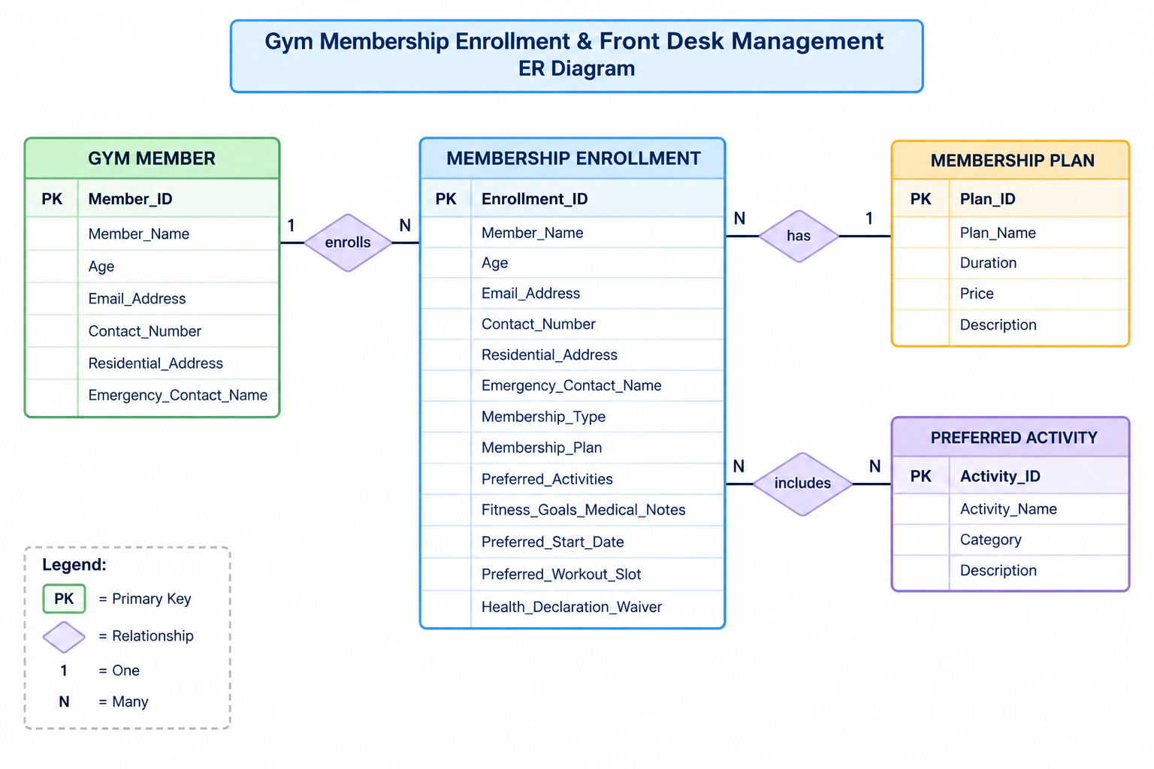
2.3 Basic Fields Used and Their Mapping
The table below maps every Basic Field from the Zoho Creator Form Builder palette to its role in the Gym Membership Enrollment Form
Basic Field | Form Field Name | Purpose
Name | Member_Name | Captures the full name of the prospective member using First/Last name sub-fields
Email | Email_Address | Captures a validated email address for enrollment confirmation and schedule
Address | Residential_Address | Captures the member's full residential address with city, state, and pincode
Phone | Contact_Number | Captures a validated mobile number for enrollment confirmation and reminders
Single Line | Emergency_Contact_Name | Captures the name of an emergency contact person
Multi Line | Fitness_Goals_Medical_Notes | Captures the member's fitness goals and relevant medical conditions
Number | Age | Captures the member's age
Date | Preferred_Start_Date | Captures the preferred date to begin the membership
Time | Preferred_Workout_Slot | Captures the preferred daily workout time
Drop Down | Membership_Plan | Provides a single-select list of membership plans
Radio | Membership_Type | Captures a single mandatory enrollment category
Multi Select | Preferred_Activities | Allows selection of one or more fitness activities/classes
Checkbox | Health_Declaration_Waiver | Captures the member's health declaration and acceptance of the gym's liability waiver

2.4 Form Layout

Section A — Member Details
- Member Name (First Name, Last Name)
- Age (Number field)
- Membership Type (Radio: New Member / Renewal / Corporate Enrollment)
Section B — Contact Details
- Email Address (Email field)
- Contact Number (Phone field)
- Residential Address (Address field)
- Emergency Contact Name (Single Line)
Section C — Membership & Fitness Preferences
- Membership Plan (Drop Down)
- Preferred Activities (Multi Select)
- Fitness Goals / Medical Notes (Multi Line)
Section D — Scheduling & Health Declaration
- Preferred Start Date (Date field)
- Preferred Workout Slot (Time field)
- I declare my fitness to exercise and accept the liability waiver (Checkbox)
LC-02-Gym Membership
2.5 Validation Rules
- Mandatory Fields: Member Name, Phone, Age, Membership Type, Membership Plan, and Waiver Checkbox.
- Email: Built-in email format validation enabled.
- Phone: Country code format enabled for Indian numbers.
- Age: Restricted from 14 to 75.
- Preferred Start Date: Past dates are not allowed.
- Health Declaration: The form cannot be submitted unless the checkbox is checked.
3. Output
The following figures show the live preview of the form and the submitted admission enquiry records in the
report view:
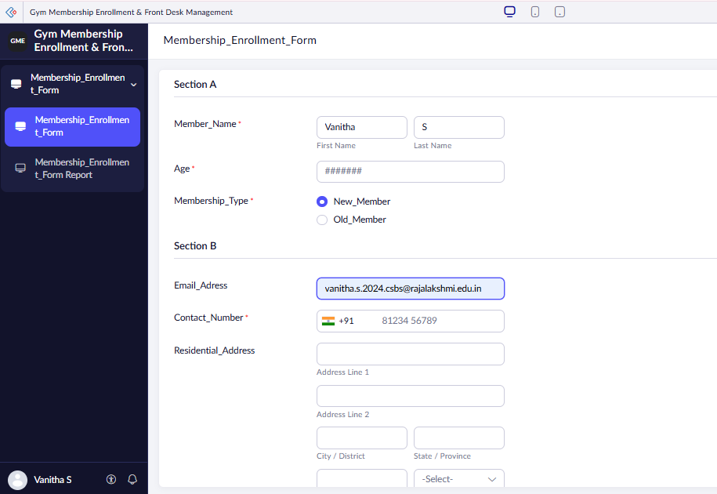

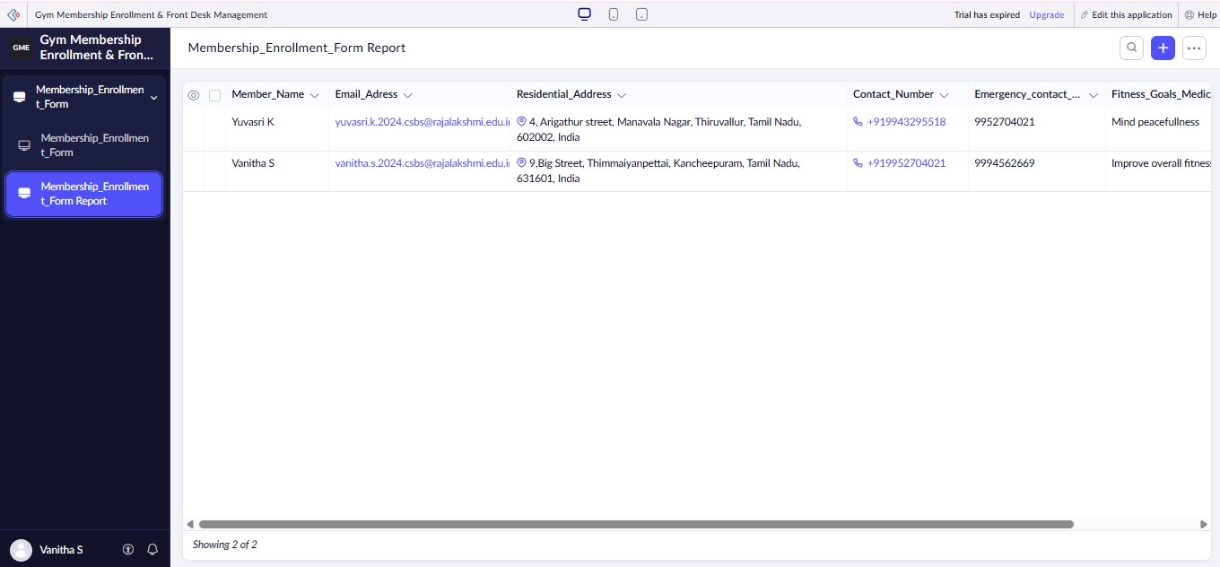

. Result
Thus, the Gym Membership Enrollment Form was successfully created using Zoho Creator with all 13 Basic Fields, required validations, and a report to manage member enrollment details. LC-02-Gym Membership

